

Sri Lanka Institute of Information Technology

Individual Assignment 02
IE3102-Enterprise Standards for Information Security

Report on ISO 27001 Implementation for an Organization

Student Registration Number | Student Name
IT23292918 | T D S D Kumarage

ISMS Objectives, Clauses, and Implementation Procedures for CyberLabs

1.0 Introduction & ISMS Overview
This document provides the detailed procedures necessary to implement, operate, and maintain an Information Security Management System (ISMS) in accordance with ISO/IEC 27001:2022 at CyberLabs. These procedures translate the standard's requirements into actionable steps for our teams.

CyberLabs's ISMS is built on the Plan-Do-Check-Act (PDCA) model, as shown below, ensuring continuous improvement:
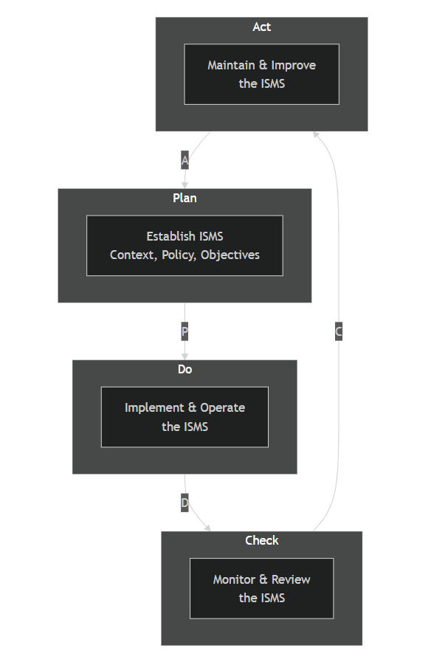

The primary security objectives for our ISMS are:

- Confidentiality: Protecting client and company data from unauthorized access.
- Integrity: Ensuring the accuracy and completeness of all critical information.
- Availability: Guaranteeing that IT services and data are accessible to authorized users when needed.

2.0 Core Implementation Procedures

2.1 Information Security Risk Assessment & Treatment
Objective: To establish a consistent and effective process for identifying, analyzing, evaluating, and treating information security risks.
Roles & Responsibilities:
- Risk Owner: Department Head or Asset Owner (e.g., CTO for source code).
- Responsible for Execution: Information Security Officer (ISO).
- Responsible for Approval: ISMS Steering Committee (ISSC).

Procedure Steps:
Step 1: Risk Identification & Analysis
- The ISO initiates the process annually or after a significant change (trigger event).
- Using the Asset Register (CL-REG-ASSET-001), the ISO and Risk Owners identify threats and vulnerabilities for each asset.
- Impact is rated on a scale of 1-5 based on the consequence to Confidentiality, Integrity, and Availability (CIA).
- Likelihood is rated on a scale of 1-5 based on the probability of occurrence.

The Risk Matrix below is used to determine the Inherent Risk Score:
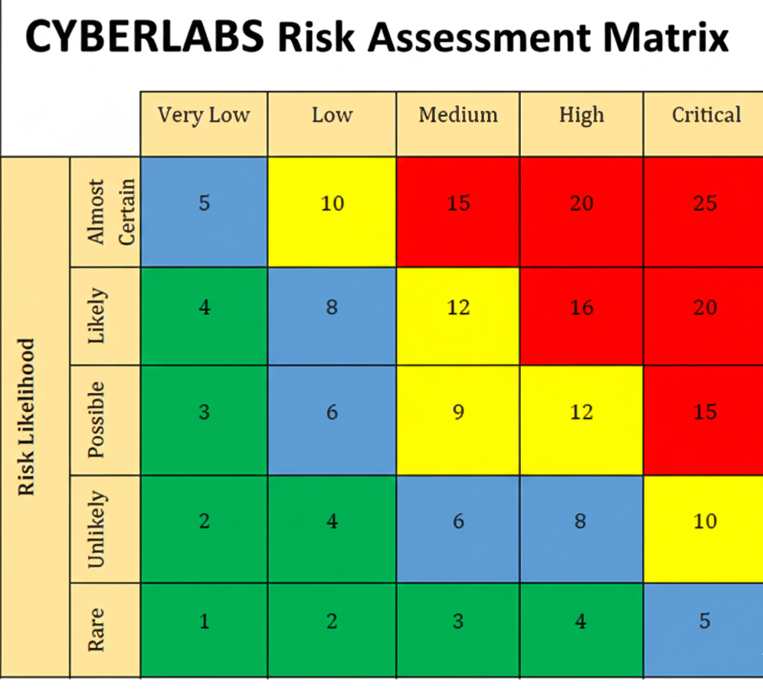

Step 2: Risk Evaluation & Treatment
- Inherent Risk is calculated as Impact x Likelihood.
- Existing Controls are assessed. Their effectiveness reduces the Likelihood and/or Impact, resulting in a Residual Risk score.
- Risks are treated according to the following criteria:

Residual Risk Score | Risk Level | Treatment & Approval Required
1 - 5 | Low | Accept. No action required. Document decision.
6 - 12 | Medium | Treat. Plan must be created and executed within 6-12 months. Approved by Risk Owner.
13 - 25 | High | Urgent Treatment. Plan must be executed within 1-6 months. Approved by ISSC.

Example from CyberLabs's Risk Register:

Asset | Threat | Inherent Risk | Existing Controls | Residual Risk | Risk Treatment Plan
Client Database | Unauthorized Access | 20 (High) | Basic Firewall | 12 (High) | 1. Implement Next-Gen Firewall.  2. Enforce MFA for all admin accounts.  3. Conduct quarterly vuln. scans.

Step 3: Review & Monitoring
- The Risk Register is a live document maintained by the ISO.
- The ISSC reviews the status of risk treatment plans quarterly.

2.2 Physical & Environmental Security
Objective: To prevent unauthorized physical access, damage, and interference to CyberLabs's premises and information.

Procedure: Physical Access Control
- Head Office & Server Room: Access is controlled by an electronic card system. All access attempts are logged.
- Visitors: Must be pre-approved, sign in at reception, and be escorted at all times. A visitor log is maintained.
- Delivery/Loading Areas: These areas are segregated from secure zones. Unattended packages are reported to security.

The following access level model is enforced:
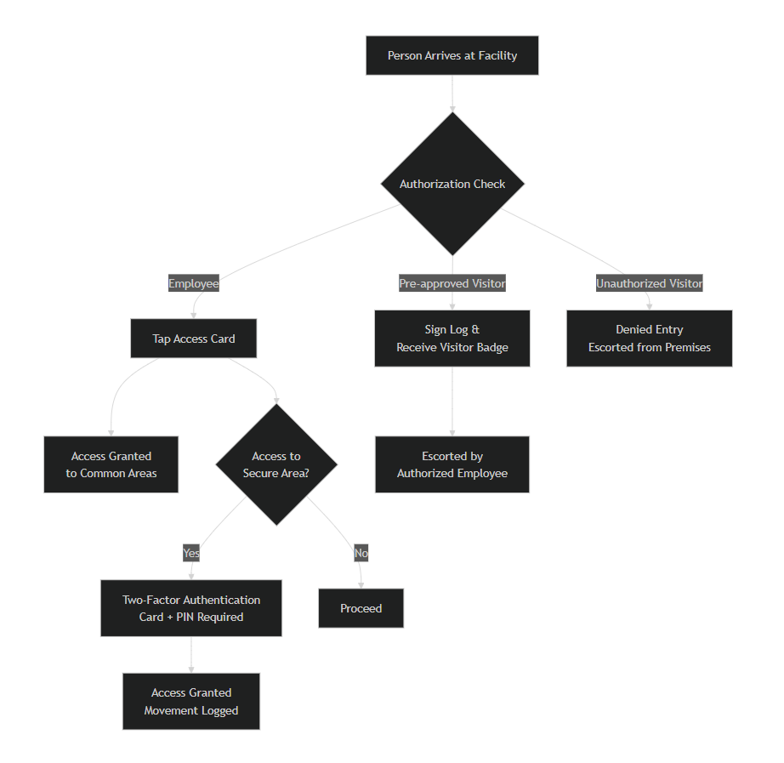

Procedure: Environmental Protection
- Server Room: Temperature and humidity are continuously monitored. Alerts are sent to the IT Operations team.
- Power: An Uninterruptible Power Supply (UPS) and backup generator are installed to maintain operations during a power outage.
- Fire Suppression: An inert-gas fire suppression system is installed to protect equipment without damage.

2.3 Access Control Management
Objective: To ensure authorized user access and prevent unauthorized access to information systems.
Procedure: User Access Lifecycle
The lifecycle of a user's system access is managed as follows:
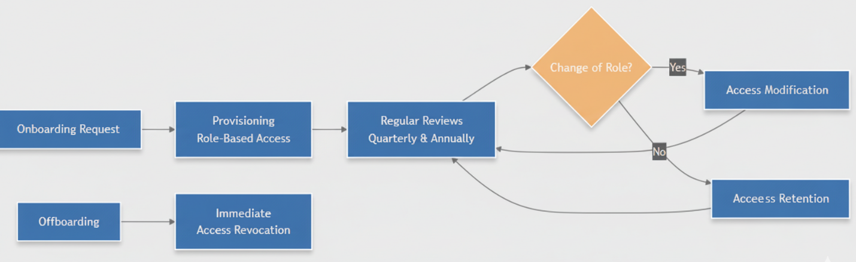

Key Rules:
- Principle of Least Privilege: Users are granted only the access necessary to perform their job functions.
- Password Policy: Passwords must be a minimum of 12 characters, complex, and changed every 90 days. Multi-Factor Authentication (MFA) is mandatory for all remote access and administrative accounts.
- Access Reviews: The ISO and HR department will conduct quarterly reviews of administrative accounts and annual reviews of all user accounts.

2.4 Security Incident Management
Objective: To ensure a consistent and effective approach to the management of information security incidents.

Procedure: Incident Response Workflow
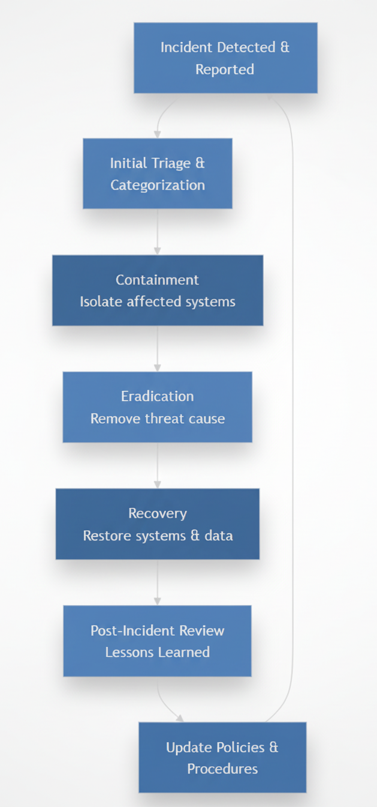
Roles:
- All Employees: Must report any suspected incident immediately to the IT Help Desk or ISO.
- IT Operations Team: Responsible for initial triage, containment, eradication, and recovery.
- Information Security Officer (ISO): Leads the investigation, coordinates the response, and conducts the post-incident review.
- ISMS Steering Committee (ISSC): Informed of major incidents and approves any significant corrective actions.

2.5 Security Awareness & Training Program
Objective: To ensure all employees and contractors are aware of their information security responsibilities and are equipped to follow CyberLabs's security policies.
Procedure:
- Induction Training: All new hires must complete a mandatory online security awareness module within their first week.
- Annual Refresher Training: All staff must complete an updated security awareness course annually.
- Phishing Simulations: The ISO will conduct quarterly simulated phishing campaigns to reinforce training.
- Specialized Training: Role-based training (e.g., for developers on secure coding) is provided annually.

3.0 Related Documents & Templates
This procedure document is supported by the following templates and registers, which are part of the complete ISMS toolkit:
- Asset Register
- Risk Register & Treatment Plan
- Roles & Responsibilities Matrix
- Incident Reporting Form
- Access Request Form

